**Uganda country profile**

Published

10 May 2018

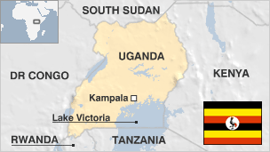

**Landlocked Uganda has transformed itself from a country with a troubled past to one of relative stability and prosperity.**

Since its independence from Britain in 1962, the east African nation has endured a military coup, followed by a brutal military dictatorship which ended in 1979, disputed elections in 1980 and a five-year war that brought current President Yoweri Museveni to power in 1986.

The country has also had to contend with a brutal 20-year insurgency in the north, led by the Lord's Resistance Army.

While the country has won praise for its vigorous campaign against HIV/AIDS it has also attracted international attention for its hardening stance against the LGBT community.

* Read more profiles by [BBC Monitoring](http://bbc.co.uk/monitoring)

**President: Yoweri Museveni**

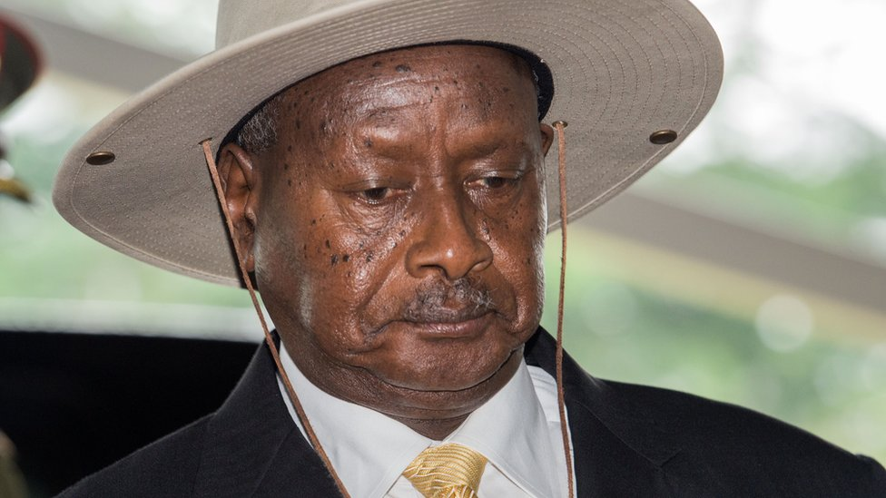image copyrightGetty Images

Yoweri Museveni and his National Resistance Movement have ruled Uganda without interruption since seizing power in 1986.

He won the 2011 presidential elections after a 2005 constitutional amendment lifted presidential term limits, and went on to win again in 2016. The opposition and independent observers have complained about the fairness and transparency of these and earlier polls.

In 2017 parliament voted to remove the 75-year age limit for presidential candidates, clearing the way for Mr Museveni to run for a sixth term in office.

Mr Museveni has been credited with restoring relative stability and economic prosperity to Uganda following years of civil war and repression under former leaders Milton Obote and Idi Amin.

But he has also faced UN criticism for his role in the conflict in DR Congo. More recently, Uganda has been accused of aiding rebels there.

Uganda is a pioneer in the liberalisation of the media in Africa.

It boasts a vibrant media sector, with nearly 200 private radio stations and dozens of television stations and print outlets, although circulation numbers have declined in recent years.

# Uganda profile - Timeline

Published

10 May 2018

**A chronology of key events:**

**1500** - Bito dynasties of Buganda, Bunyoro and Ankole founded by Nilotic-speaking immigrants from present-day southeastern Sudan.

**1700** - Buganda begins to expand at the expense of Bunyoro.

**1800** - Buganda controls territory bordering Lake Victoria from the Victoria Nile to the Kagera river.

**1840s** - Muslim traders from the Indian Ocean coast exchange firearms, cloth and beads for the ivory and slaves of Buganda.

**1862** - British explorer John Hanning Speke becomes the first European to visit Buganda.

**1875** - Bugandan King Mutesa I allows Christian missionaries to enter his realm.

## British influence

**1877** - Members of the British Missionary Society arrive in Buganda.

**1879** - Members of the French Roman Catholic White Fathers arrive.

**1890** - Britain and Germany sign treaty giving Britain rights to what was to become Uganda.

**1892** - Imperial British East Africa Company agent Frederick Lugard extends the company's control to southern Uganda and helps the Protestant missionaries to prevail over their Catholic counterparts in Buganda.

**1894** - Uganda becomes a British protectorate.

**1900** - Britain signs agreement with Buganda giving it autonomy and turning it into a constitutional monarchy controlled mainly by Protestant chiefs.

**1902** - The Eastern province of Uganda transferred to the Kenya.

**1904** - Commercial cultivation of cotton begins.

**1921** - Uganda given a legislative council, but its first African member not admitted till 1945.

**1958** - Uganda given internal self-government.

**1962** - Uganda becomes independent with Milton Obote as prime minister and with Buganda enjoying considerable autonomy.

**1963** - Uganda becomes a republic with Buganda's King Mutesa as president.

**1966** - Milton Obote ends Buganda's autonomy and promotes himself to the presidency.

**1967** - New constitution vests considerable power in the president.

## Idi Amin years

**1971** - Milton Obote toppled in coup led by Army chief Idi Amin.

**1972** - Amin orders Asians who were not Ugandan citizens - around 60,000 people - to leave the country.

**1972**-**73** - Uganda engages in border clashes with Tanzania.

**1976** - Idi Amin declares himself president for life and claims parts of Kenya.

**1978** - Uganda invades Tanzania with a view to annexing Kagera region.

**1979** - Tanzania invades Uganda, unifying the various anti-Amin forces under the Uganda National Liberation Front and forcing Amin to flee the country; Yusufu Lule installed as president, but is quickly replaced by Godfrey Binaisa.

**1980** - Binaisa overthrown by the army.

Milton Obote becomes president after elections.

**1985** - Obote deposed in military coup and is replaced by Tito Okello.

**1986** - National Resistance Army rebels take Kampala and install Yoweri Museveni as president.

## Beginnings of recovery

**1993** - Museveni restores the traditional kings, including the king of Buganda, but without political power.

**1995** - New constitution legalises political parties but maintains the ban on political activity.

**1996** - Museveni returned to office in Uganda's first direct presidential election.

**1997** - Ugandan troops help depose Mobutu Sese Seko of Zaire, who is replaced by Laurent Kabila.

**1998** - Ugandan troops intervene in the Democratic Republic of Congo on the side of rebels seeking to overthrow Kabila.

**2000** - Ugandans vote to reject multi-party politics in favour of continuing Museveni's "no-party" system.

**2001** January - East African Community (EAC) inaugurated in Arusha, Tanzania, laying groundwork for common East African passport, flag, economic and monetary integration. Members are Tanzania, Uganda and Kenya.

**2001** March - Uganda classifies Rwanda, its former ally in the civil war in DR Congo, as a hostile nation because of fighting in 2000 between the two countries' armies in DR Congo.

Museveni wins another term in office, beating his rival Kizza Besigye by 69% to 28%.

## Campaign against rebels

2002 March - Sudan, Uganda sign agreement aimed at containing Ugandan rebel group the Lord's Resistance Army (LRA), active along common border.

**2002** October - Army evacuates more than 400,000 civilians caught up in fight against cult-like LRA which continues its brutal attacks on villages.

**2002** December - Peace deal signed with Uganda National Rescue Front (UNRF) rebels after more than five years of negotiations.

**2003** May - Uganda pulls out last of its troops from eastern DR Congo. Tens of thousands of DR Congo civilians seek asylum in Uganda.

**2004** February - LRA rebels slaughter more than 200 people at a camp for displaced people in the north.

**2004** December - Government and LRA rebels hold their first face-to-face talks, but there is no breakthrough in ending the insurgency.

**2005** April - Uganda rejects accusations made by DR Congo at the International Court in The Hague. DR Congo says Uganda invaded its territory in 1999, killing citizens and looting.

## Multi-party politics

**2005** July - Parliament approves a constitutional amendment which scraps presidential term limits.

Voters in a referendum overwhelmingly back a return to multi-party politics.

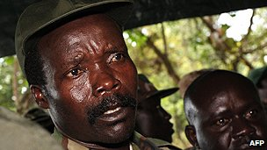image copyrightAFP

image captionLord's Resistance Army leader Joseph Kony

**2005** October - International Criminal Court issues arrest warrants for five LRA commanders, including leader Joseph Kony.

**2005** November - Main opposition leader Kizza Besigye is imprisoned shortly after returning from exile after a trial in a military court on various charges including treason and illegal possession of firearms. Supporters say the trial was politically motivated, and take to the streets. Mr Besigye is released on bail in January 2006, just ahead of presidential elections.

**2005** December - International Court in The Hague rules that Uganda must compensate DR Congo for rights abuses and the plundering of resources in the five years leading to 2003.

**2006** February - President Museveni wins multi-party elections, taking 59% of the vote against the 37% share of his rival, Kizza Besigye. EU observers highlight intimidation of Mr Besigye and official media bias as problems.

**2006** August - The government and the LRA sign a truce aimed at ending their long-running conflict. Subsequent peace talks are marred by regular walk-outs.

**2006** November - Government rejects a United Nations report accusing the army of using indiscriminate and excessive force in its campaign to disarm tribal warriors in the lawless northeastern region of Karamoja.

## Somalia role

**2007** March - Ugandan peacekeepers deploy in Somalia as part of an African Union mission to help stabilise the country.

The UN World Food Programme says it will have to halve food handouts to more than 1 million people displaced by war in the north.

**2007** April - Protests over a rain forest explode into racial violence in Kampala, forcing police to protect Asian businesses and a Hindu temple. An Asian man and two other people are killed.

**2007** July - Lord's Resistance Army says lack of funds for foreign travel and to reach commanders in remote hideouts will delay peace talks.

**2007** August - Uganda and DRCongo agree to try defuse a border dispute.

**2007** September - State of emergency imposed after severe floods cause widespread devastation.

**2008** February - Government and the Lord's Resistance Army sign what is meant to be a permanent ceasefire at talks in Juba, Sudan.

**2008** November - The leader of the Lord's Resistance Army, Joseph Kony, again fails to turn up for the signing of a peace agreement. Ugandan, South Sudanese and DR Congo armies launch offensive against LRA bases.

**2009** January - Lord's Resistance Army appeals for ceasefire in face of continuing offensive by regional countries.

The UK oil explorer Heritage Oil says it has made a major oil find in Uganda.

**2009** March - Ugandan army begins to withdraw from DR Congo, where it had pursued Lord's Resistance Army rebels.

**2009** October - Somali Islamists threaten to target Uganda and Burundi after action by African peacekeepers in Somalia kills several civilians.

**2009** December - Parliament votes to ban female circumcision. Anyone convicted of the practice will face 10 years in jail or a life sentence if a victim dies.

**2010** January - President Museveni distances himself from the anti-homosexuality Bill, saying the ruling party MP who proposed the bill did so as an individual. The European Union and United States had condemned the bill.

The Ugandan army says it killed Bok Abudema, a senior commander of the Lord's Resistance Army armed group, in the Central African Republic.

**2010** February - Heritage Oil sells its assets in Uganda to the UK firm Tullow Oil after Italian energy company Eni dropped out of the bidding.

**2010** June - Public prosecutor opens corruption investigation against Vice-President Gilbert Bukenya, Foreign Minister Sam Kutesa and several other ministers and officials over the alleged theft of $25m.

**2010** June-August - Operation Rwenzori against ADF-NALU rebels striving for an Islamic state in Uganda prompts 90,000 to flee in North Kivu province of neighbouring DR Congo.

## Blasts

**2010** July - Two bomb attacks on people watching World Cup final at a restaurant and a rugby club in Kampala kill at least 74 people. The Somali Islamist group Al-Shabab says it was behind the blasts.

**2010** August - National Resistance Movement primary elections for parliamentary and local candidates suspended amid irregularities, violence.

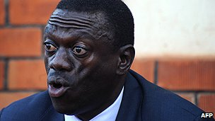image copyrightAFP

image captionOpposition leader Kizza Besigye

**2010** October - UN report into killing of Hutus in DR Congo between 1993 and 2003 says they may constitute "crimes of genocide". It implicates Rwanda, Uganda, Burundi, Zimbabwe and Angola.

**2010** October - Constitutional Court quashes treason charges against opposition leader Kizza Besigye.

**2011** February - Museveni wins his fourth presidential election. Challenger Kizza Besigye alleges vote-rigging and dismisses the result as a sham.

**2011** April - Kizza Besigye arrested several times over ''walk-to-work'' protests against rising prices.

**2011** July - US deploys special forces personnel to help Uganda combat LRA rebels.

**2011** September - Court orders release of LRA commander Thomas Kwoyelo, saying he should be given the amnesty on offer from the government.

**2012** May - Ugandan Army captures senior LRA commander Caesar Achellam in a clash in the Central African Republic, one of the nearby states in which the remaining band of LRA troops operates. Uganda says this is a major breakthrough, billing Achellam as a top LRA strategist.

Tens of thousands of refugees cross into Uganda, fleeing fighting in DR Congo.

## DR Congo allegations

**2012** July - UN accuses Uganda of sending troops into DR Congo to fight alongside the M23 rebel movement, a charge Uganda denies.

**2012** November - Uganda announces its intention to withdraw from UN-backed international peacekeeping missions in response to UN accusations that Uganda is arming Congolese rebels.

Britain and other European countries halt aid channelled through the Ugandan government amid a scandal involving the alleged theft of donor funds.

**2013** February - Eleven countries, including Uganda, sign a UN-mediated agreement pledging not to interfere in DR Congo.

**2013** March - Uganda is grouped among the worst offenders in the illegal ivory trade at a meeting of CITES, the body regulating wildlife trade.

**2013** May - Government temporarily shuts two newspapers after they published a letter suggesting President Museveni was grooming his son for power.

**2013** November - Kampala Council ousts opposition Democratic Party Mayor Erias Lukwago over allegations of incompetence and abuse of office. The Democratic Party accuses the government of engineering the ouster of the opposition's most prominent elected representative.

**2013** December - Parliament passes controversial anti-gay bill that increases the punishment for homosexual acts to include life imprisonment.

**2014** February - President Museveni signs tough new anti-gay bill into law, drawing criticism from around the world.

The World Bank postpones a $90m (£54m) loan to Uganda over the move, and the US imposes sanctions.

**2014** July - Nearly 100 people die in clashes involving rival communities and the army in the western Rwenzori region.

**2014** September - President Museveni sacks Prime Minister Amama Mbabazi.

**2014** December - Renegade General David Sejusa, who fell out with President Museveni, unexpectedly returns from exile.

More than 1000 former fighters of the DRCongo rebel group M23 seek asylum in Uganda after government tries to repatriate them.

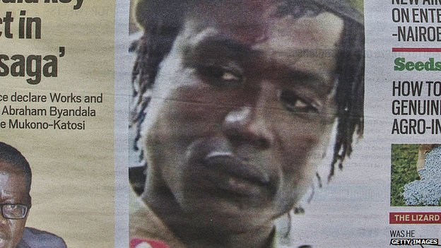image copyrightGetty Images

image captionDominic Ongwen is the first suspected member of the Lord's Resistance Army to appear before the International Criminal Court

Two Muslim clerics killed by men on motorbikes. Police suspect the Islamist Allied Democratic Forces killed the two for discouraging people from joining the rebels.

**2015** January - Dominic Ongwen becomes the first member of the Lord's Resistance Army to appear before the International Criminal Court.

**2015** October - The head of Ugandan force in South Sudan says his troops will start withdrawing to make way for a regional force.

**2016** February - President Museveni wins re-election against veteran candidate Kizza Besigye, amid opposition, Commonwealth, US and European Union concern about fairness and transparency.

**2016** May - US delegation walks out of President Museveni's inauguration in protest at his disparaging comments about the International Criminal Court.

**2016** July - Opposition leader Besigye is bailed after being held on treason charges for allegedly declaring himself president after elections.

**2016** December - The first Lord's Resistance Army commander to appear before the International Criminal Court at The Hague goes on trial. Dominic Ongwen faces 70 counts of war crimes and crimes against humanity.

**2016** November - Clashes between tribal king Charles Mumbere of Rwenzururu in western Uganda and security forces results in dozens of dead.

**2017** January - President Museveni appoints his son, General Muhoozi Kainerugaba, as a presidential advisor.

**2017** February - Four countries launch an intelligence centre in Uganda from which they will coordinate the fight against the rebel Allied Democratic Forces. The ADF started out with the aim of overthrowing President Museveni, but went on to absorb other rebel factions, and has carried out random massacres over two decades.

**2017** April - Uganda withdraws its forces from the Central African Republic where it has been fighting the Lord's Resistance Army for the past five years.

**2017** August - The UN says the number of South Sudanese refugees in Uganda has reached one million.

**2017** December - Parliament votes to remove the age-limit for presidential candidates, clearing the way for President Museveni to run for another term.